Results (Draft)

Data Cleaning/Confirmation (4 September 2026)

a. Pseudo Replication Issue

Thesis Data:
- Successfully averaged each of the 3 replicates.
- Was able to keep a record of how many of the tiles had NA values (replicates weren’t measured due to data filtering or negative flux values)
- Will report those numbers in the appendices

USGS Data:
- Found that there were some duplicates of replicates that had different values (example Site C Distance 12 meter had two Replicate a tiles, each with a different value).
- I met with McKenna this morning, and she knew that there were data bugs within the original Data Release and is already trying to parse through them with another researcher who's using the data. I sent her my list of data that has duplicates (attached if you want to look through it for fun, but not necessary). She will send me the cleaner file to analyze. For now, took excluded those Distance measured from analysis entirely.
- I asked what the original intention of using Replicate measurements was-to average or to keep individual. She expected averaging to be the intended statistical method, with error bars between replicates of the same distance.

b. Long Deployment Sampling Periods-How Does it Affect the Data?
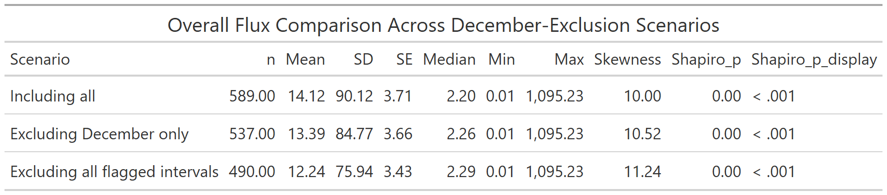
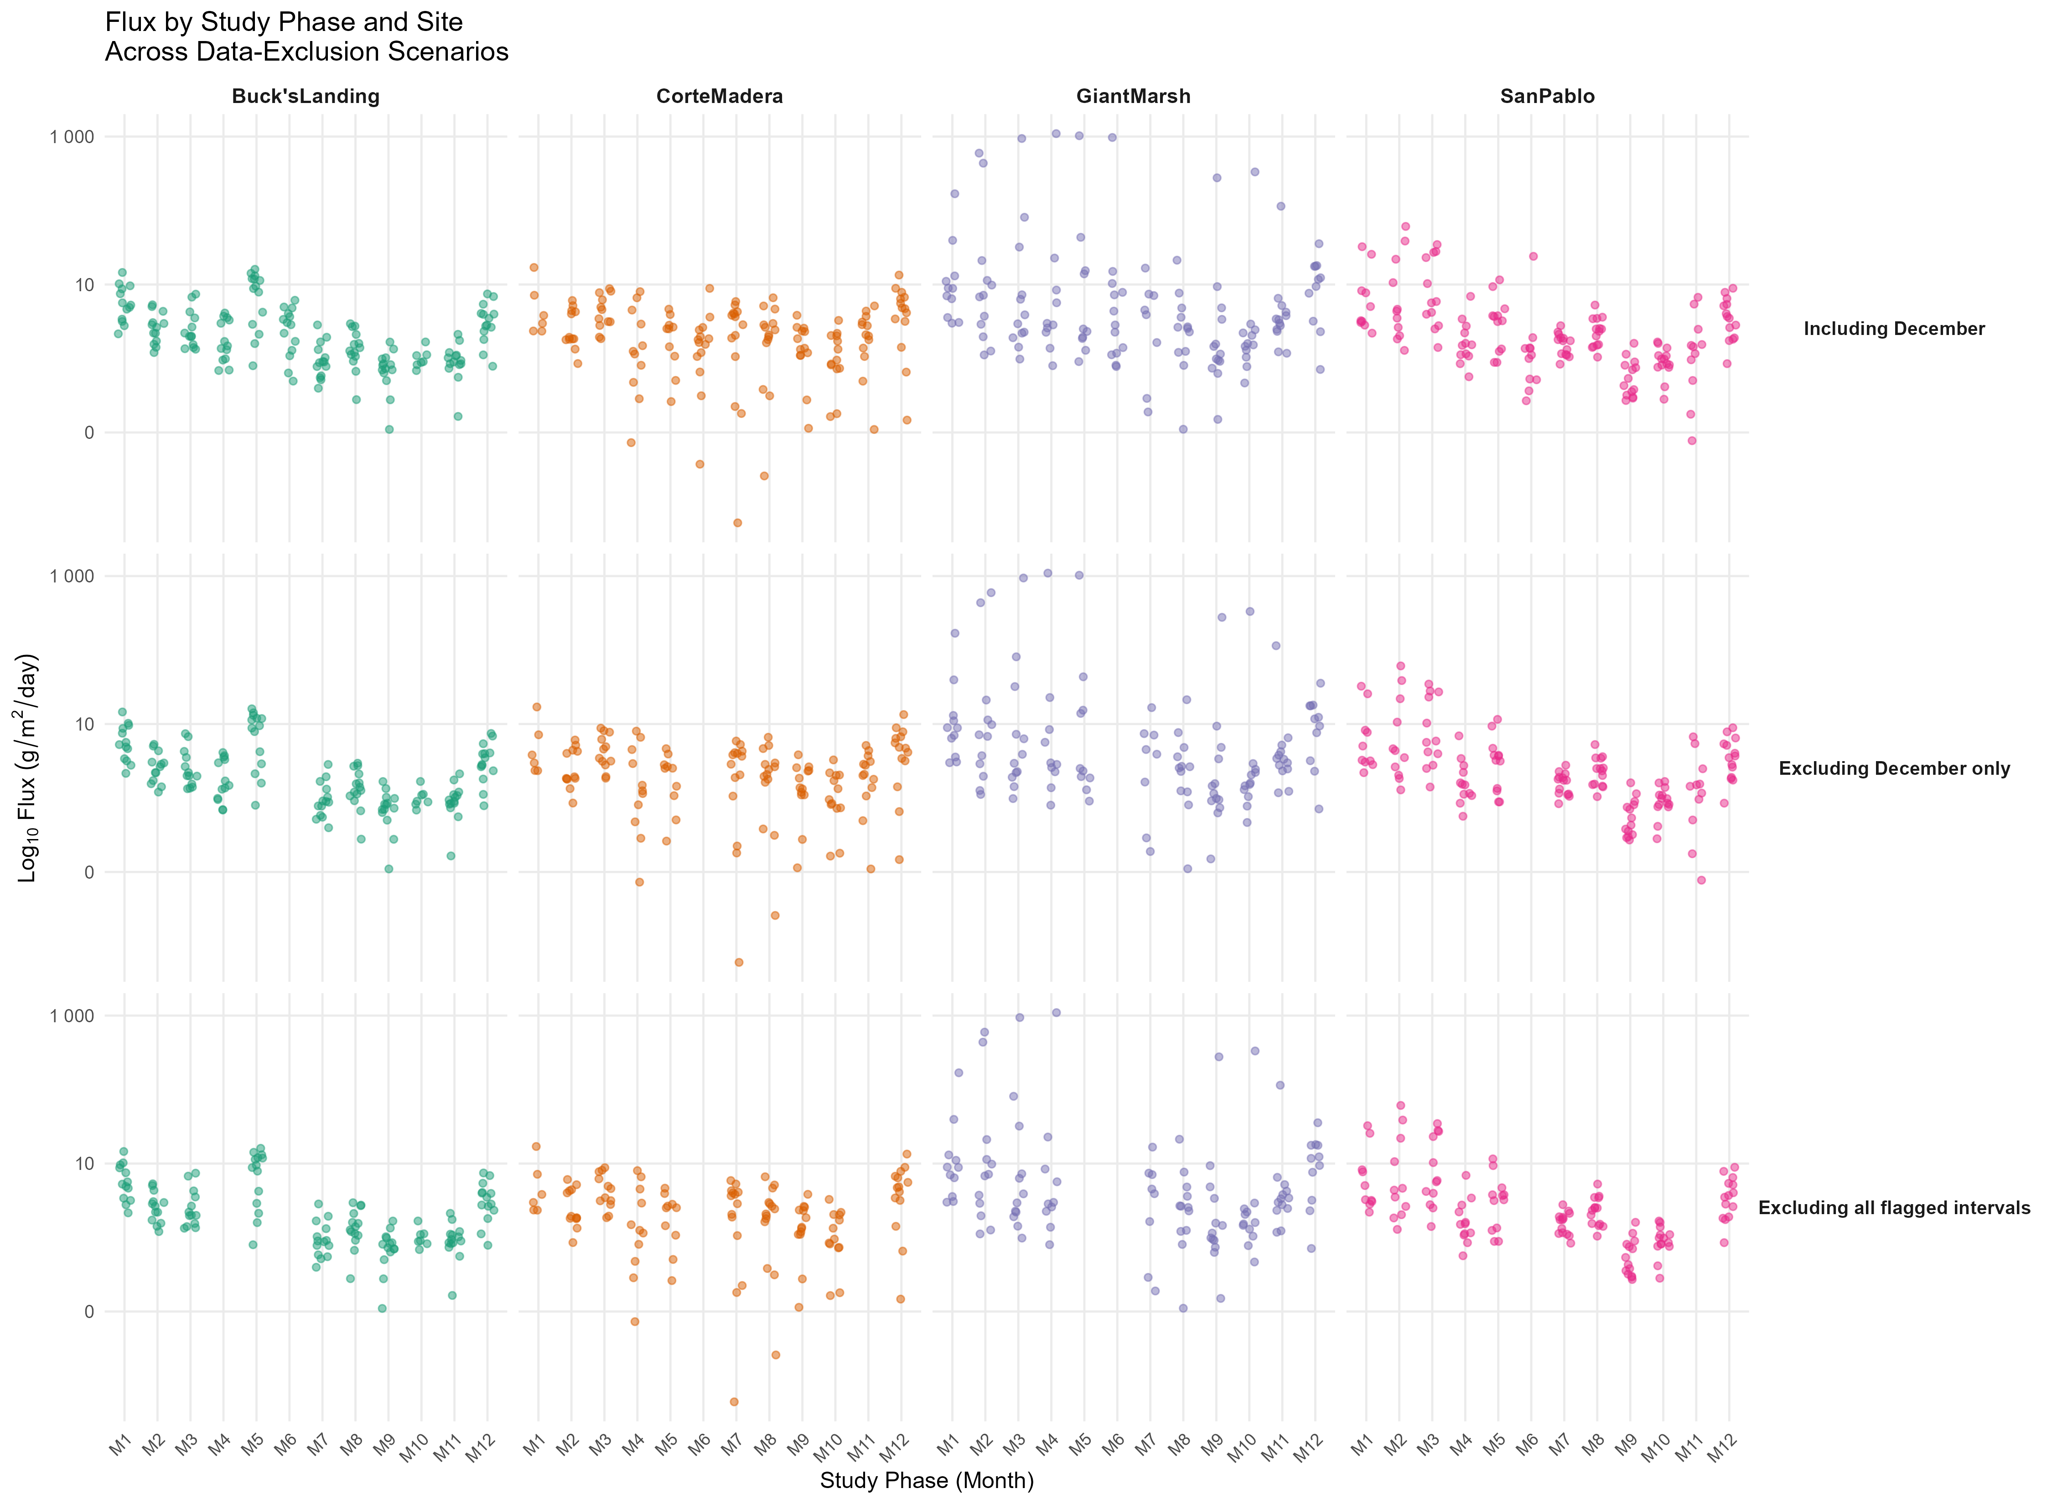
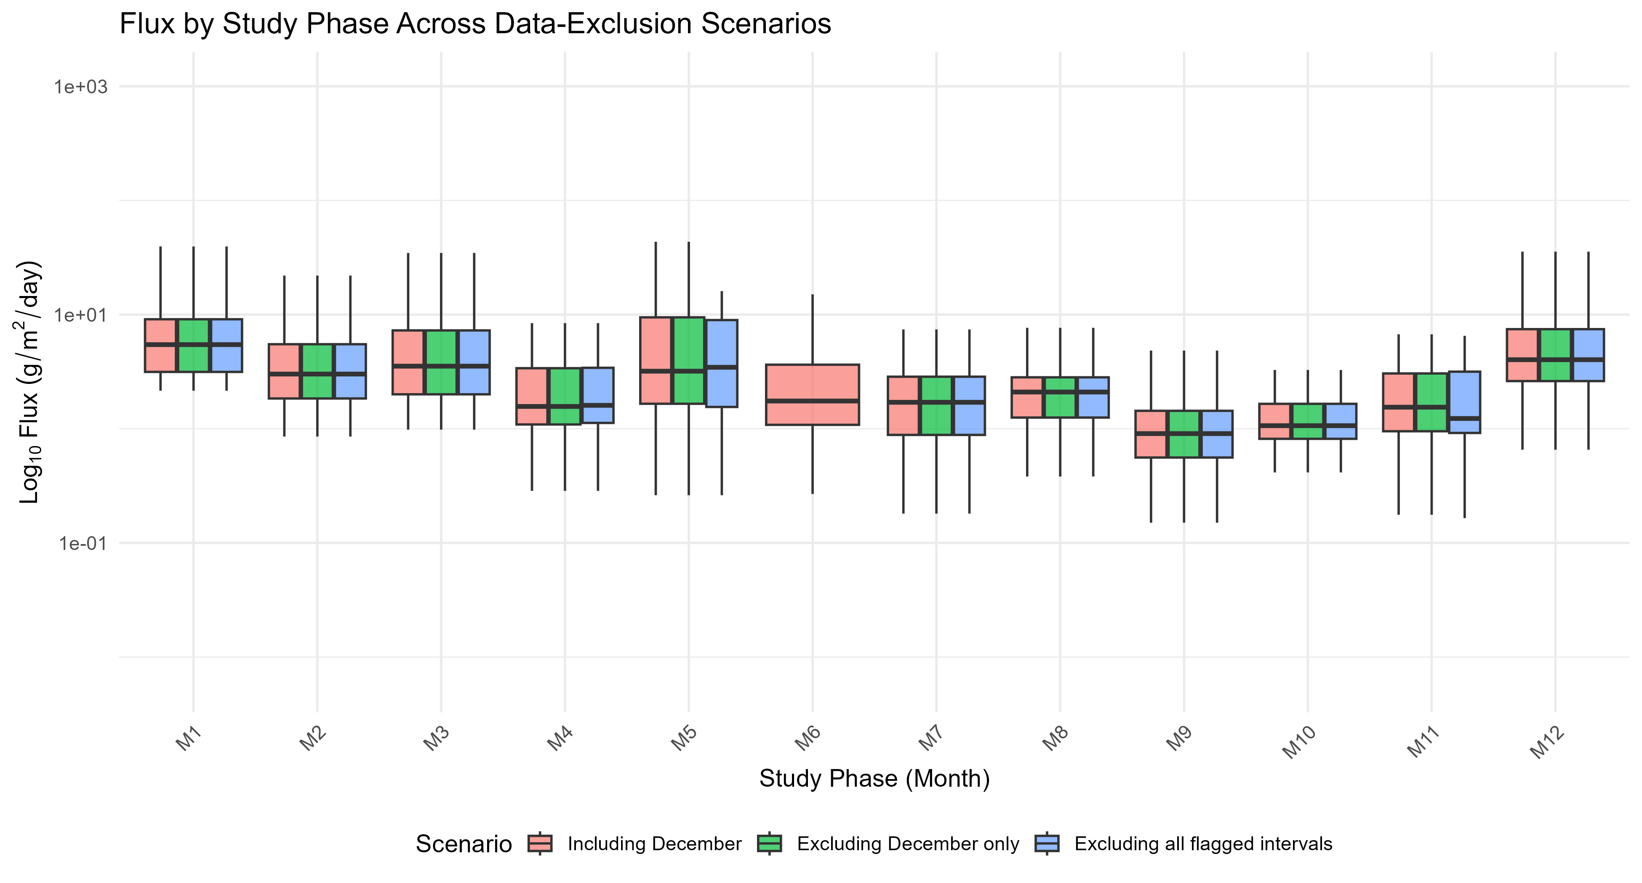
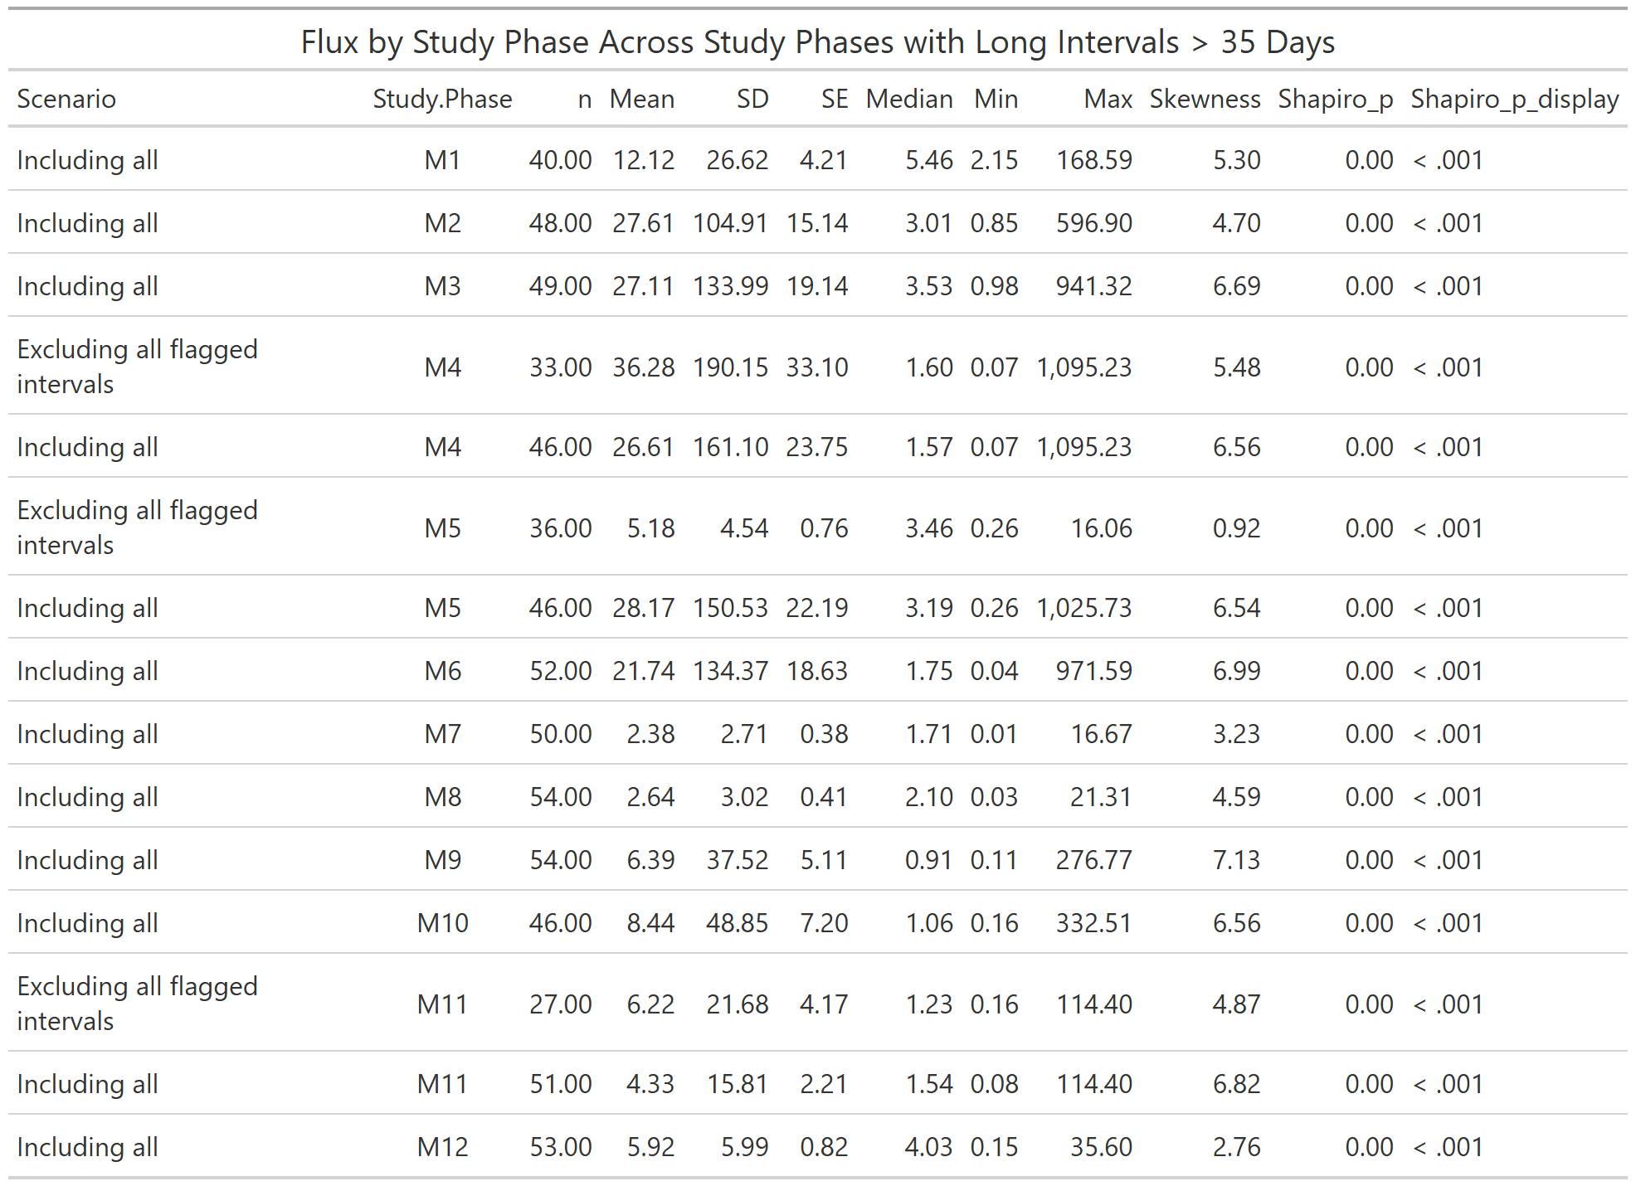

c. Shapiro p value and Statistics
- Shapiro values are indicating that the data does not fall under a normal distribution-not that the data is insignificant.
- Planning to instead use a GLMM and compare the results of that as opposed to a LMM with a log transformation to see if that changes the data
- Trying to nail down which distribution group I should use for GLMM-there aren’t too many studies that have used a

3. Results

All the results when in linear models were not significant-statistical tables complementing visualizations to demonstrate complexity

3.1 Sediment Deposition Across Ramped and Scarped Marsh Edges

a. Basic Aggregation of Ramped vs. Scarped Sites (Visualizations and Statistical Table)
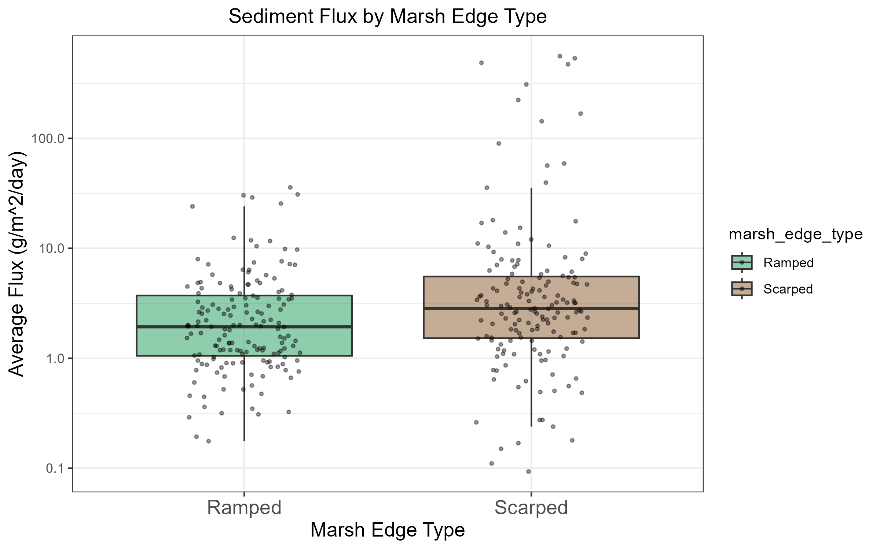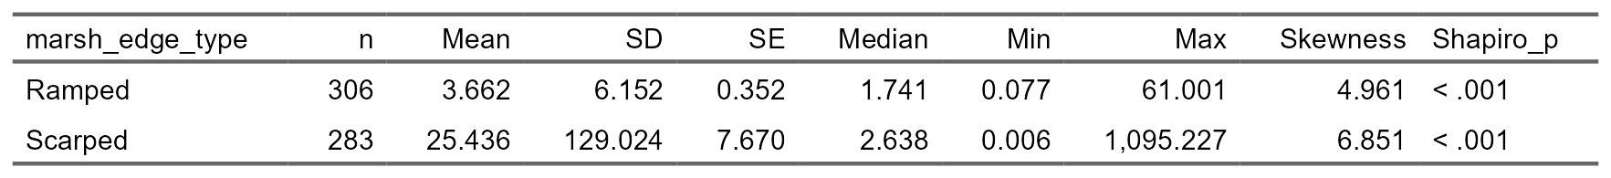

b. Site Level Detail-Color Coded still with Ramped vs. Scarped Sites (Visualizations and Statistical Table)
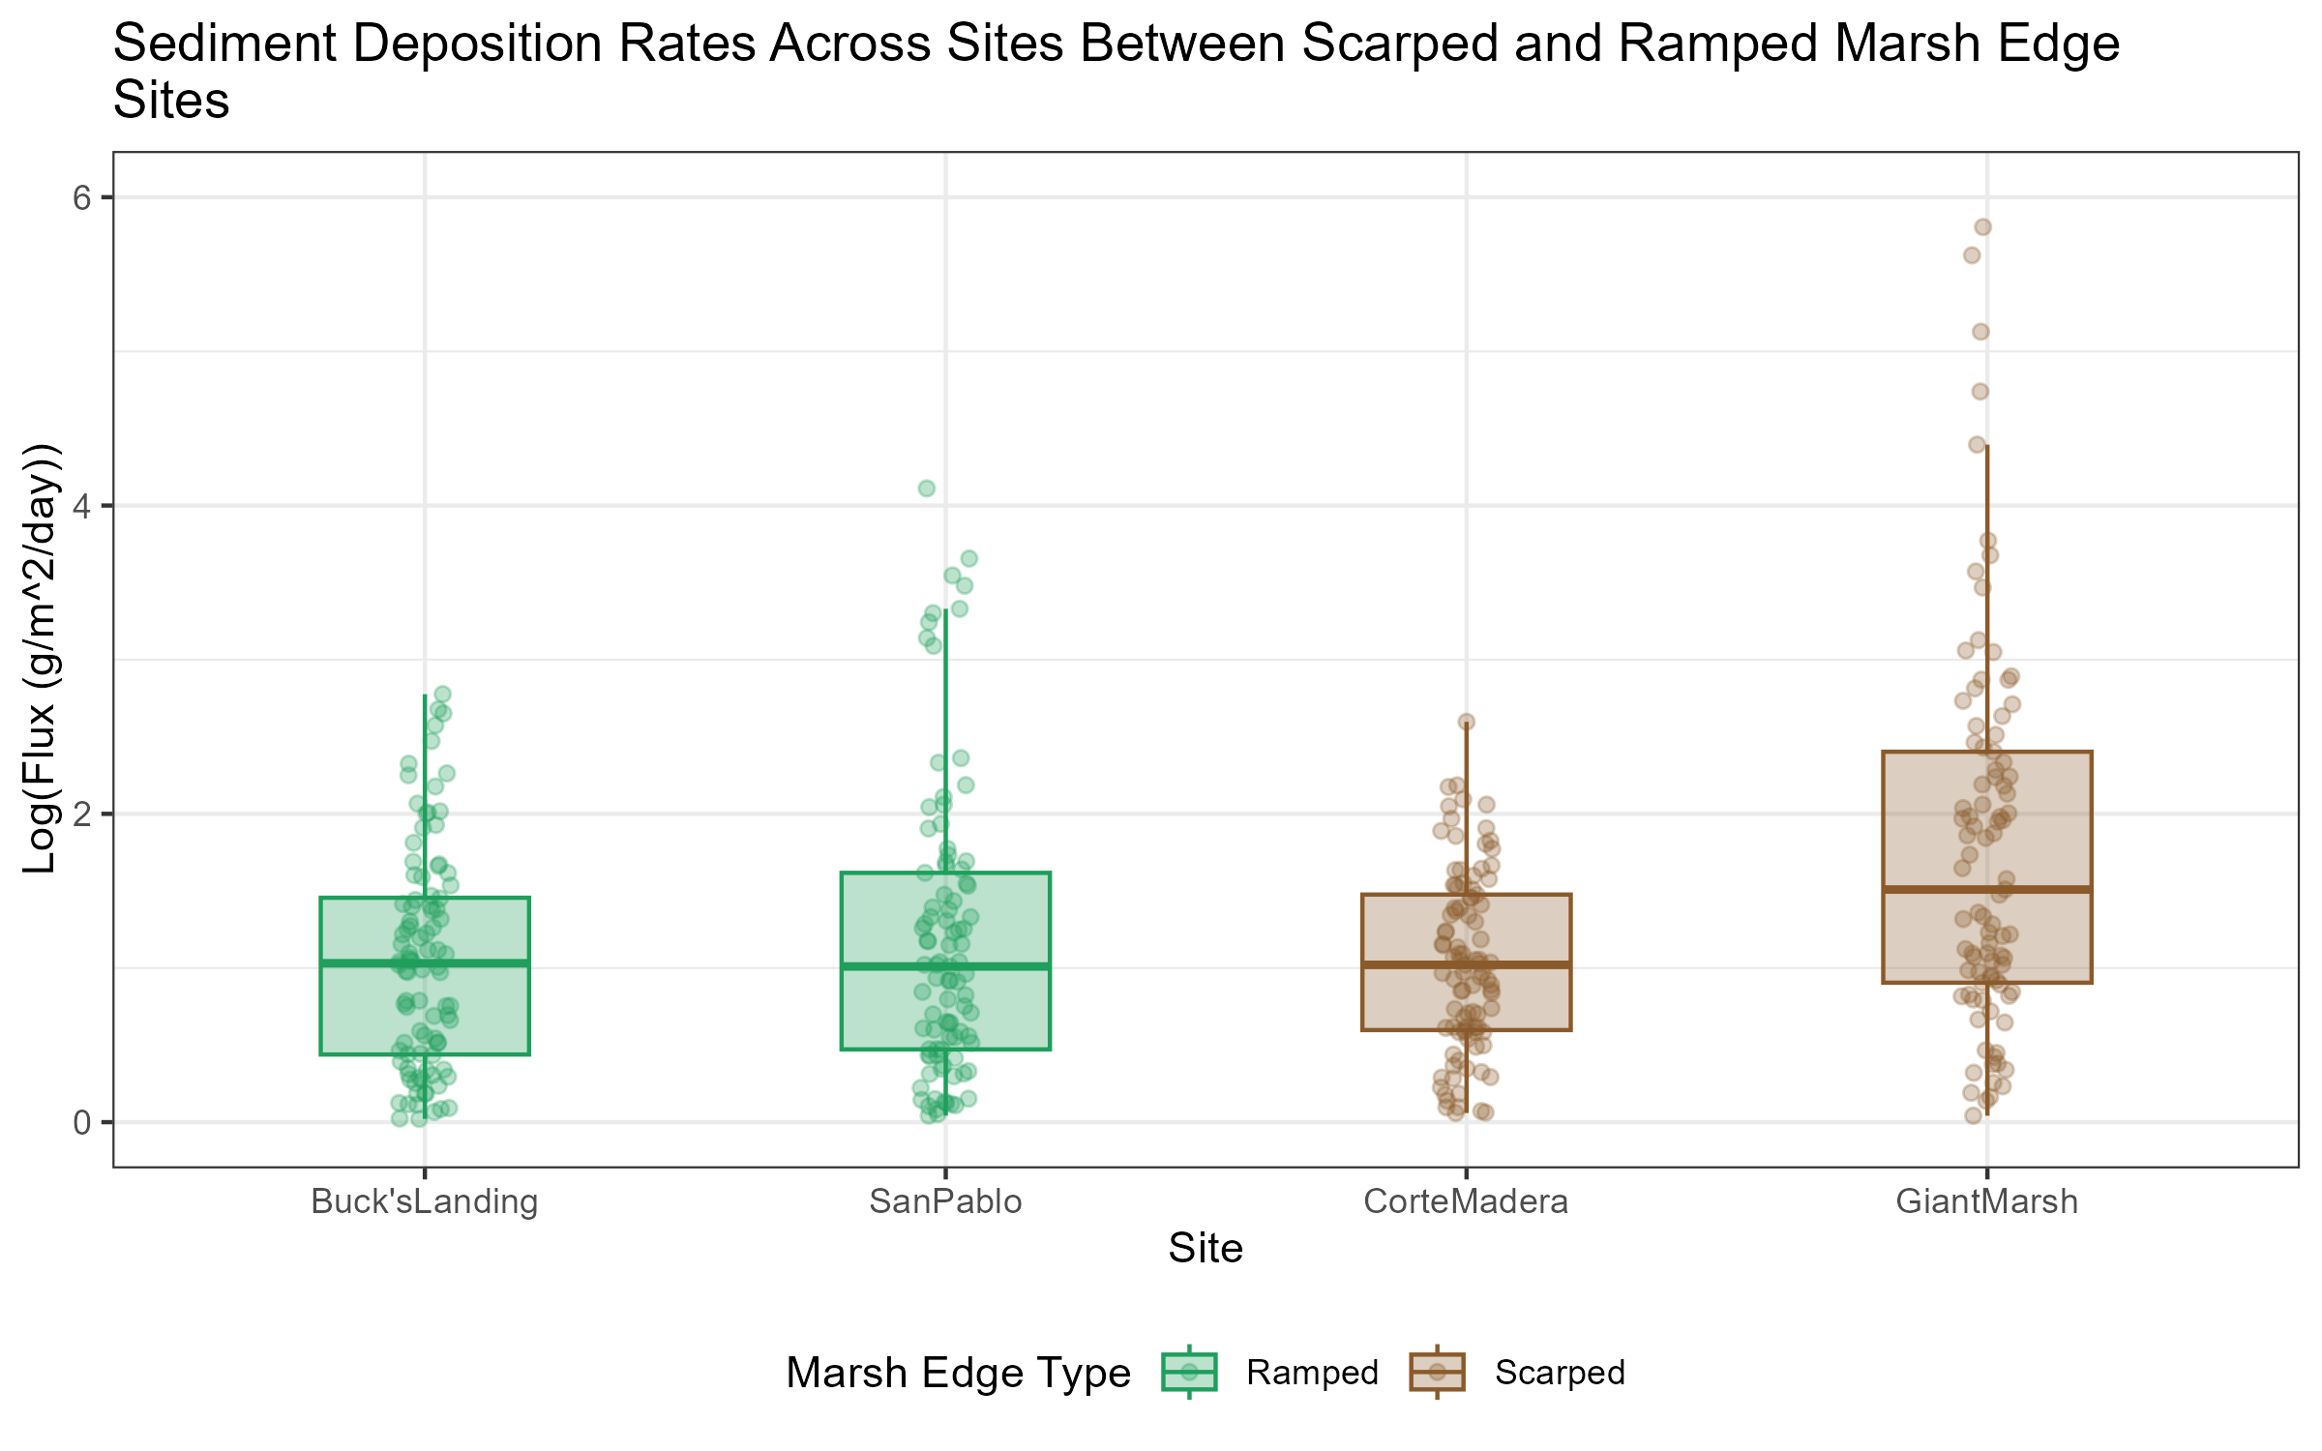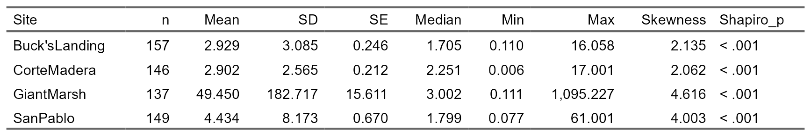

c. Within Site Level Differences of z* and Distance (Visualizations and Statistical Table)
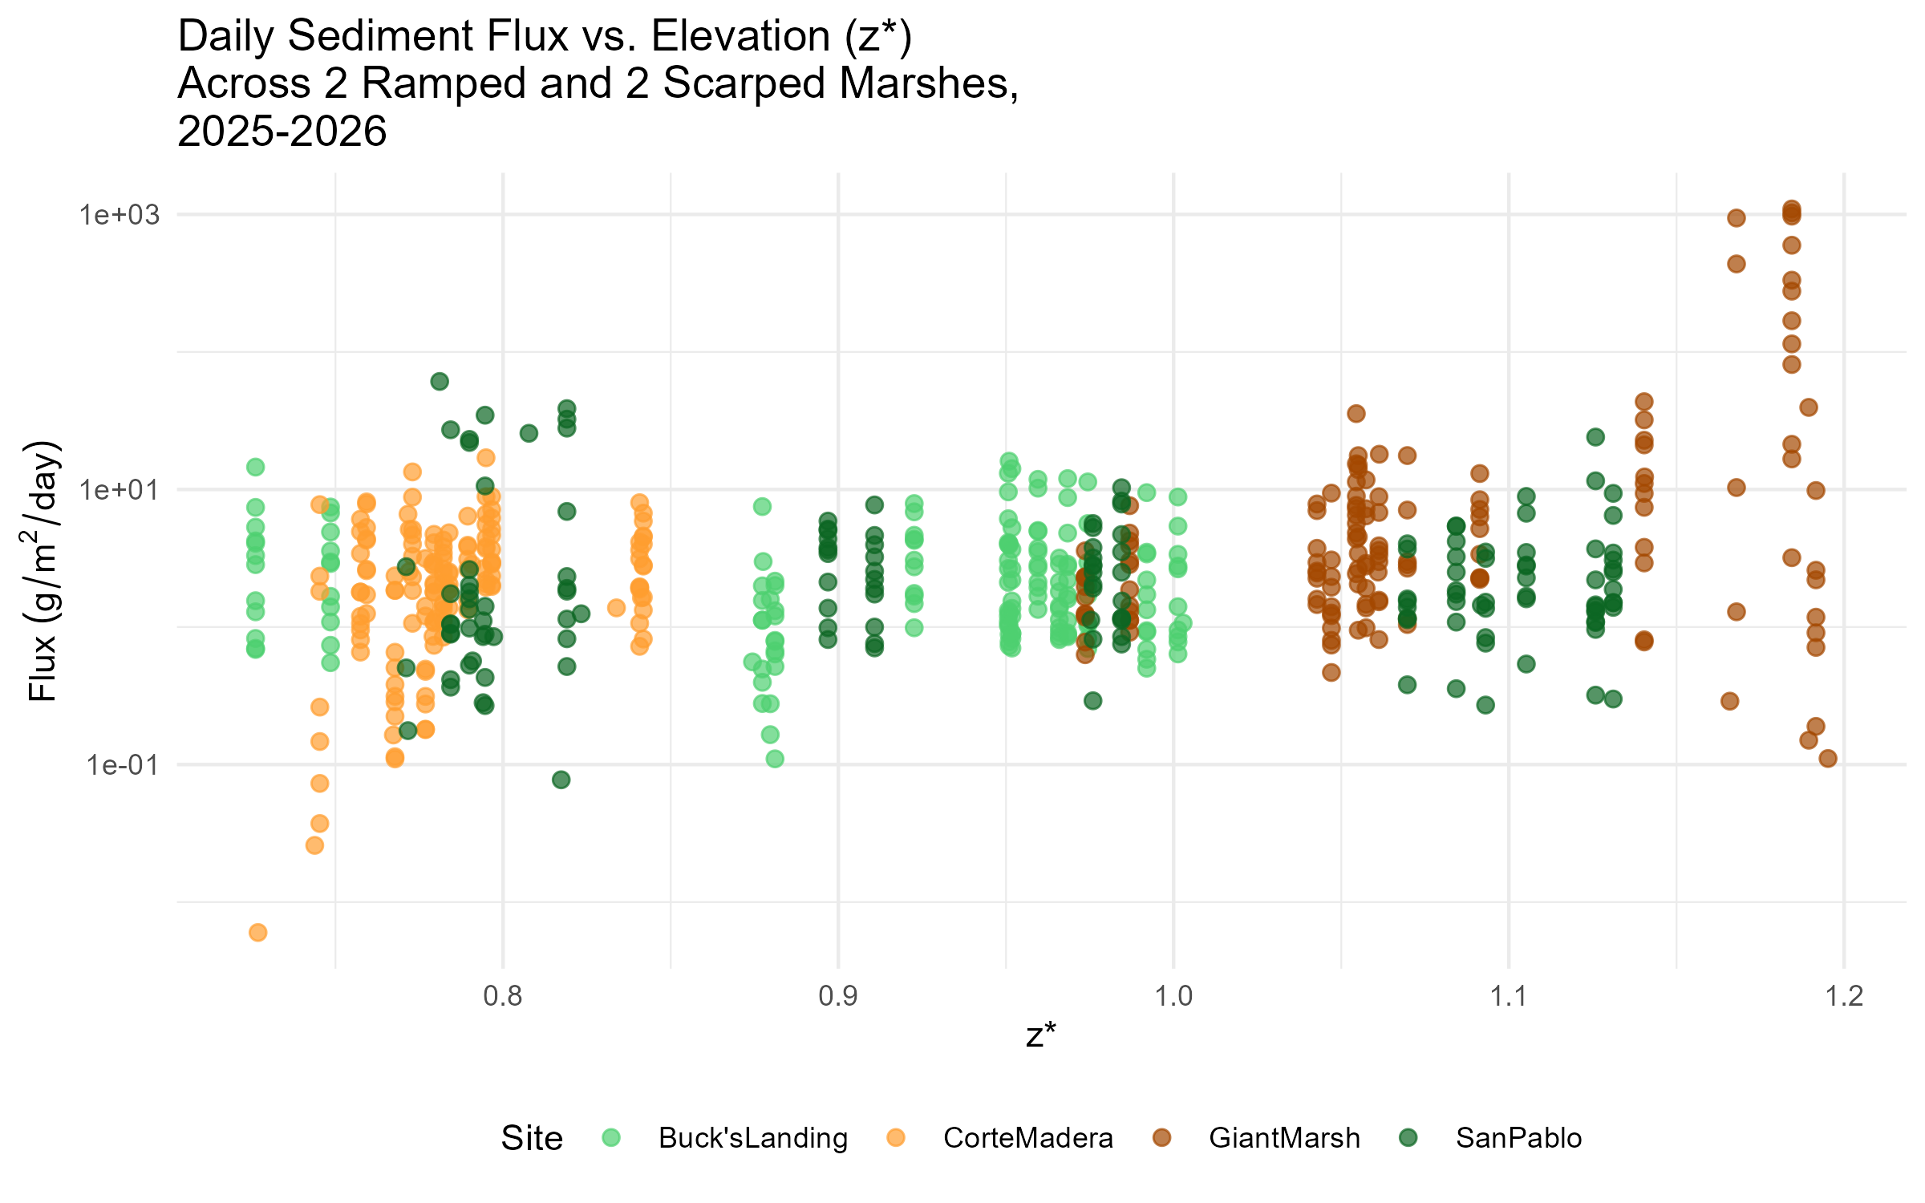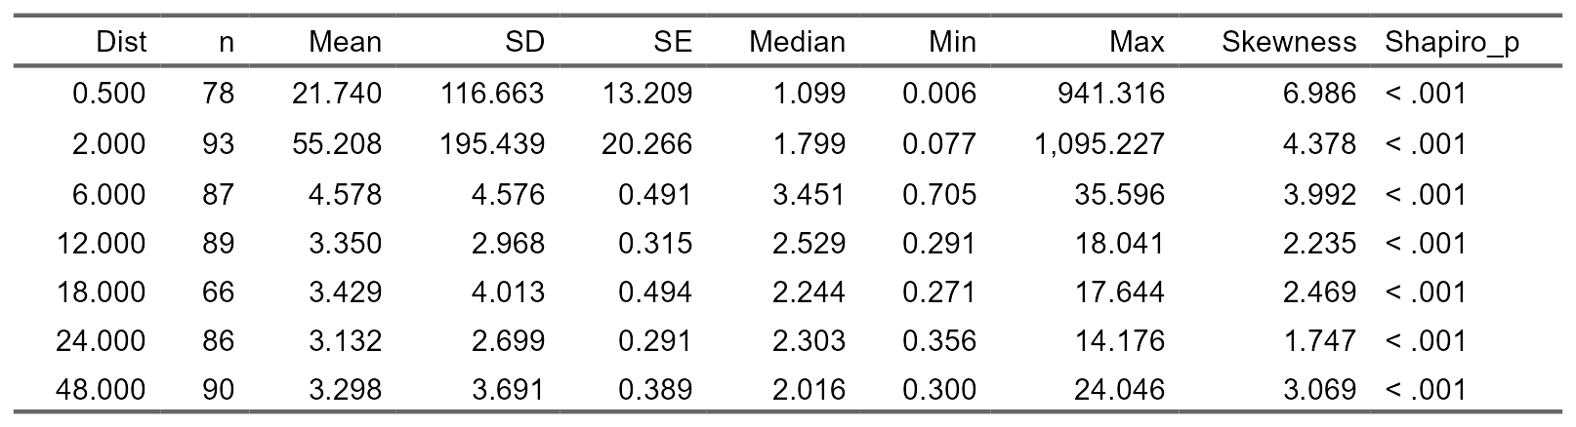

d. Within Site Level Differences Between Months Throughout the Year (Visualizations and Statistical Table)
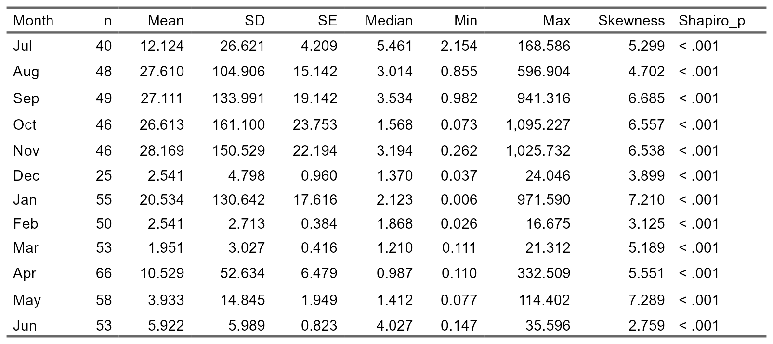

3.2 Sediment Deposition Rates Across Years in One Ramped and One Scarped Edge Marsh

a. Basic Aggregation of 2022-2023 vs. 2025-2026 comparison (Visualizations and Statistical Table)
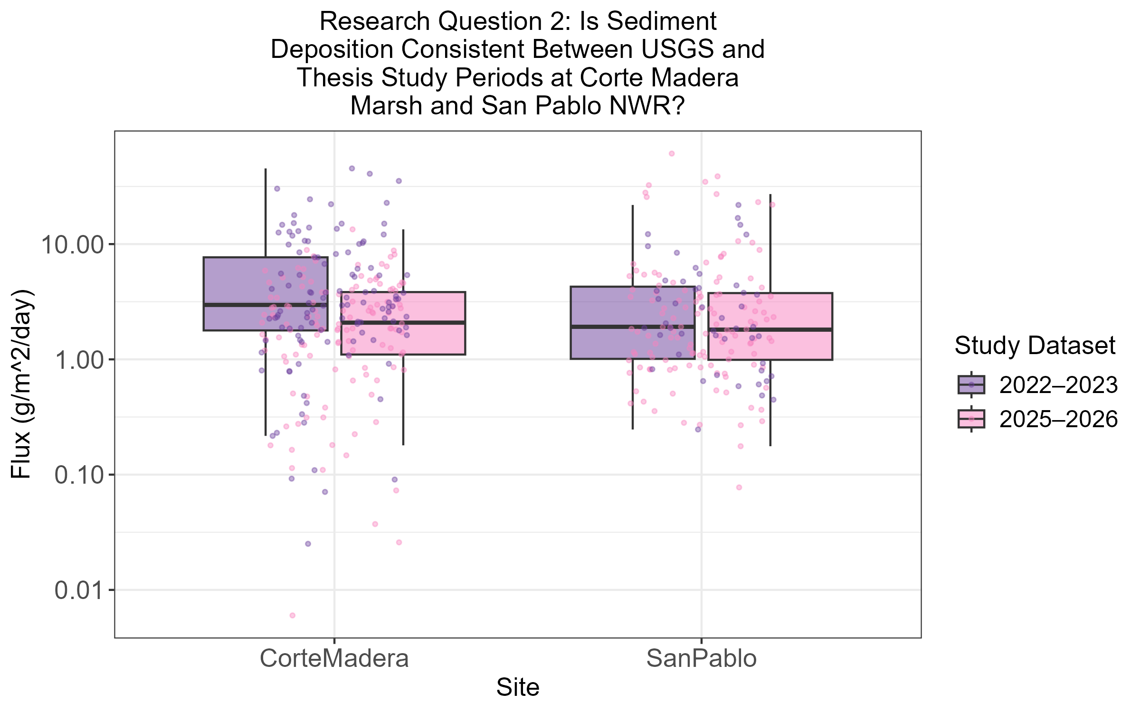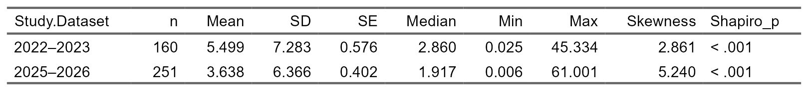

b. Site Comparison of San Pablo and Corte Madera through 2022-2023 vs. 2025-2026 (Visualizations and Statistical Table)
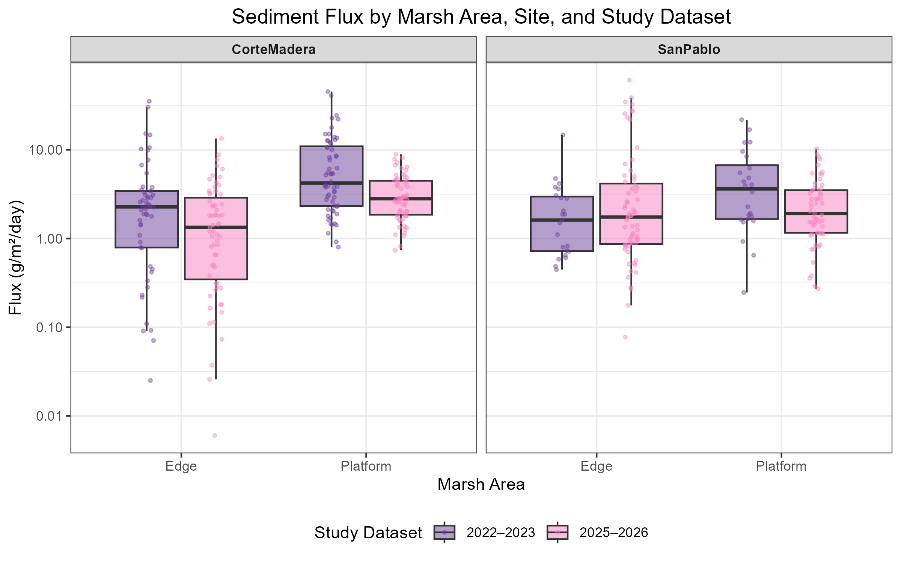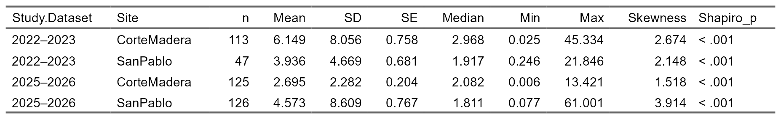

c. Seasonal Context Between Years Measured of 2022-2023 vs. 2025-2026 (Visualization)
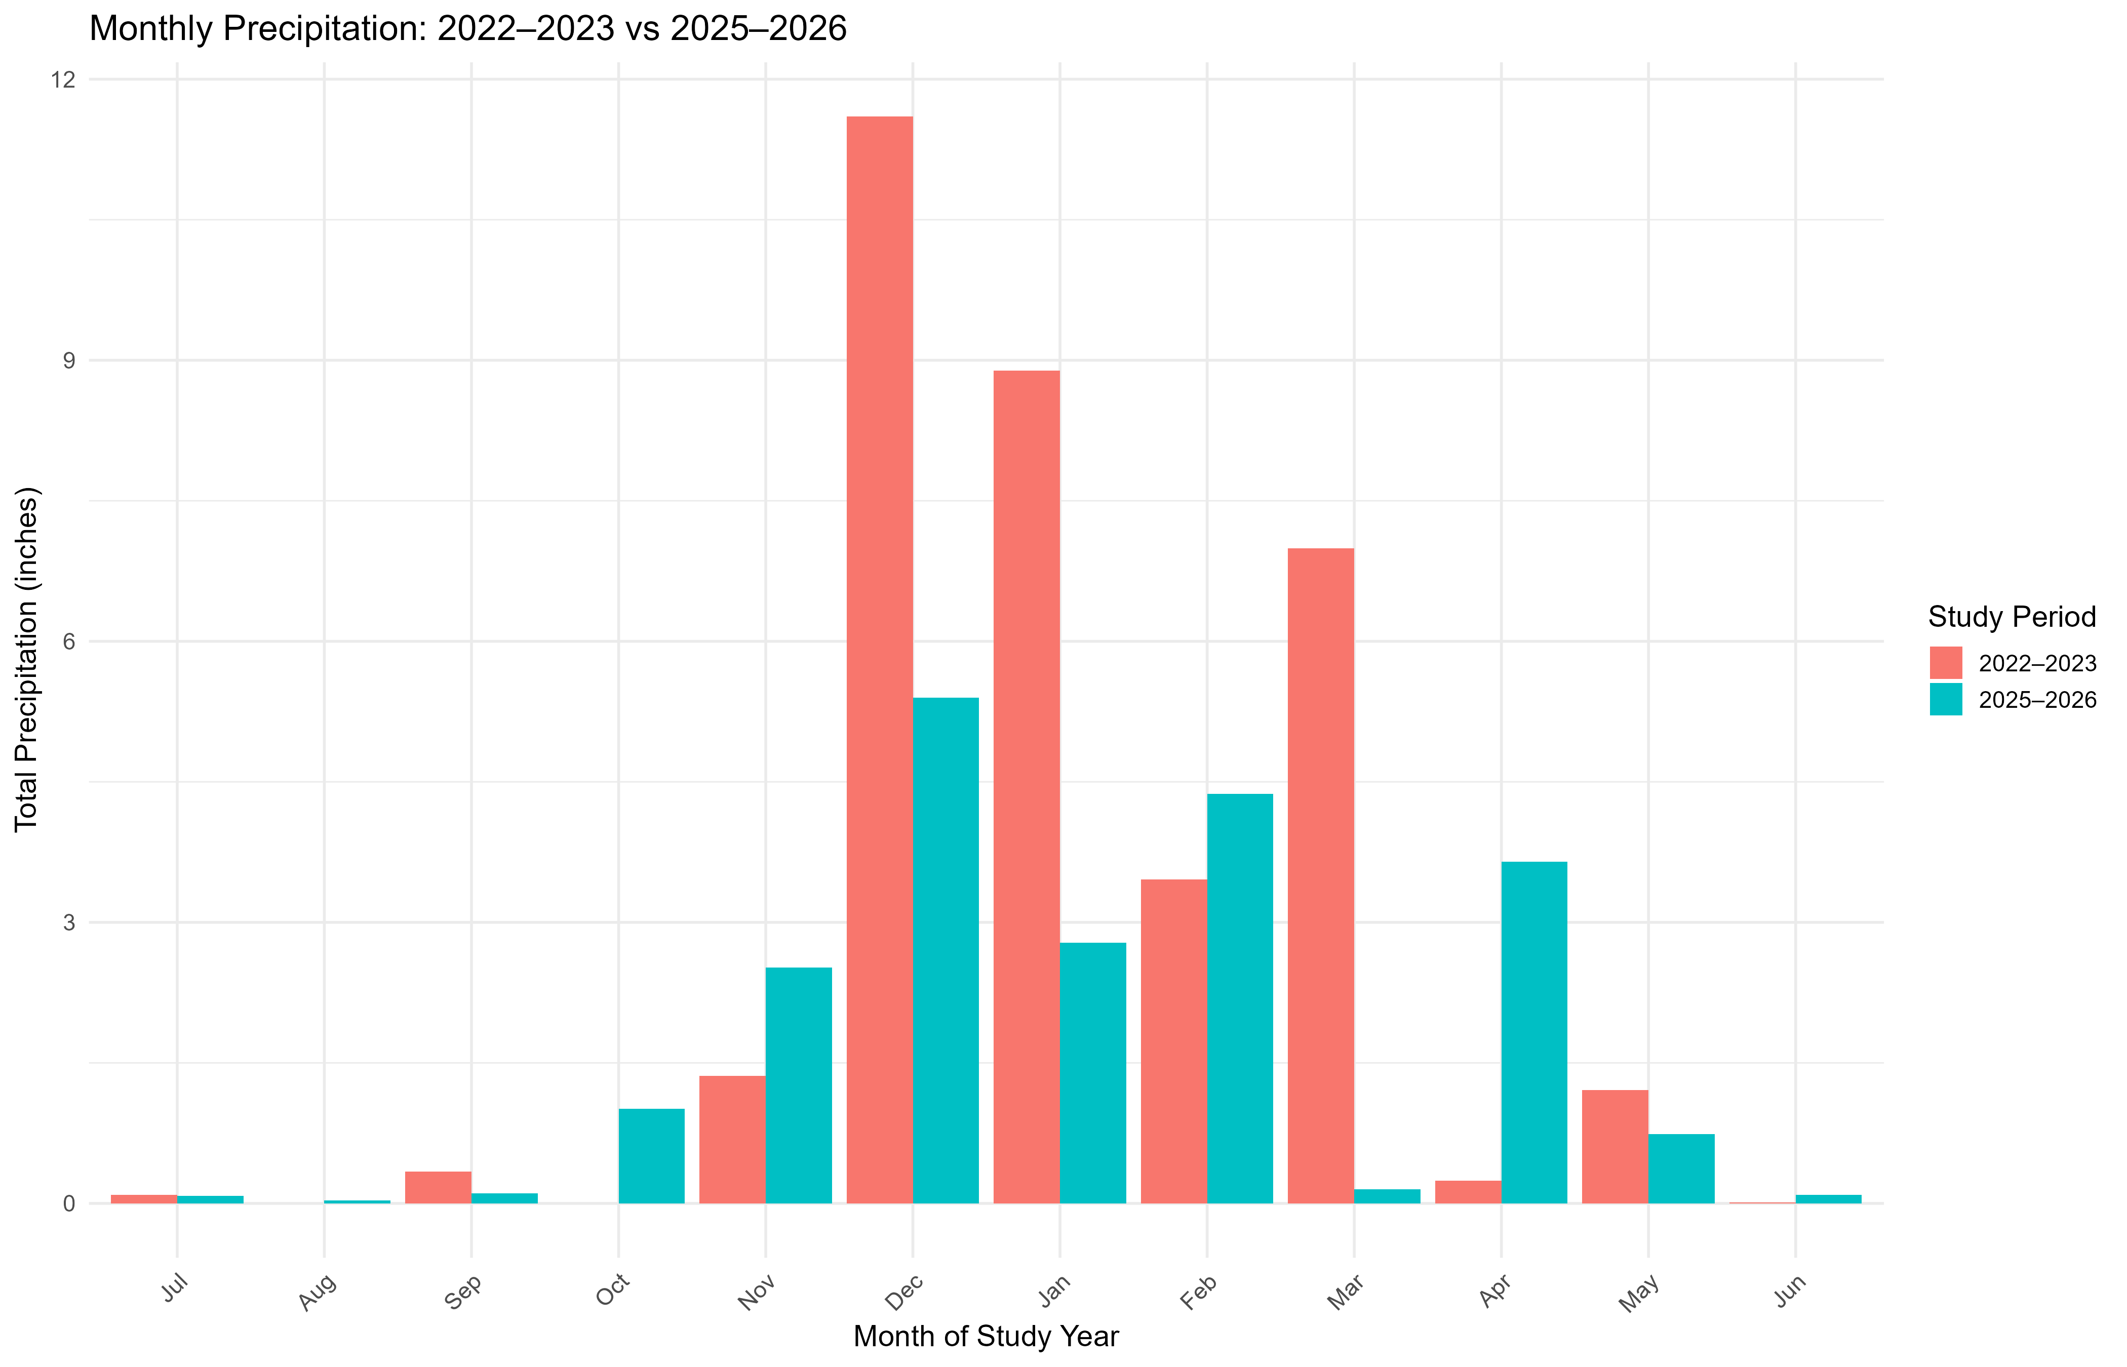

3.3 Sediment Deposition in Relation to Intra-Marsh Geomorphic Factors

a. LASSO Regression Analysis of Intra-Marsh Factors (Visualization)
